A Project Report on
MULTI-TASK CNN-TRANSFORMER FOR JOINT OTFS CHANNEL ESTIMATION AND DOPPLER-SENSING PREDICTION

submitted in partial fulfilment of the requirements for the course

MACHINE LEARNING
25SC2107E

in

A.Y.: 2026-27

by

SURAPANENI.SRIKARPRATHAP 2520040006

DUVAKULA.DAKSHESH KUMAR 2520040060

ANUMUKONDA.DHANUSH KARTHIKEYA 2520040032

Under the Esteemed guidance of

Mr. N Lava Prasad

Assistant Professor,

Department of ECE





DEPARTMENT OF ELECTRONICS & COMMUNICATION ENGINEERING

Abstract:

Orthogonal Time Frequency Space (OTFS) modulation represents wireless signals in the delay-Doppler domain and is a promising waveform for high-mobility scenarios such as high-speed trains, autonomous vehicles, unmanned aerial vehicles and 5G/6G networks. In such environments, rapid channel variation, multipath propagation, Doppler shifts and noise make accurate channel estimation and Doppler sensing difficult, and the two tasks are usually handled separately even though both depend on the same received signal. This project develops a multi-task deep learning framework that combines a Convolutional Neural Network (CNN) and a Transformer encoder to jointly perform OTFS channel estimation and Doppler-sensing prediction. The CNN extracts local features from the delay-Doppler representation of the received signal, the Transformer encoder models long-range relationships among delay-Doppler bins, and two task-specific heads produce the channel estimate and the normalised Doppler prediction from a shared representation. The model was trained on synthetic multipath OTFS data with additive white Gaussian noise using a combined loss over both tasks. Training converged smoothly over 25 epochs, with the combined loss falling from about 0.95 to 0.08 on the training set and from about 0.69 to 0.14 on the validation set. For Doppler sensing, the predicted values follow the ideal line across the normalised range, and the Low/High Doppler classification reached an accuracy of 68.2%, a precision of 82.2% and a recall of 58.0% for the High class, and a ROC area under the curve of 0.781. In channel estimation, the dominant delay-Doppler paths were located correctly, with a largest absolute error of about 2.4 on a weaker path. The results show that one shared CNN-Transformer can learn both tasks and recover the main channel structure, while recall for high Doppler values and weak-path amplitude remain areas for improvement. Future work will compare the model with conventional and single-task baselines across SNR levels.

Signature of the Supervisor Course Instructor
INDEX

Abstract ii
- Introduction 1
  - Background and Motivation 1
  - Problem Statement 1
  - Objectives 2
  - Scope and Contributions 2
  - Organization of the Report 3
- Background and Related Work 4
  - Wireless Channels in High-Mobility Scenarios 4
  - Orthogonal Time Frequency Space Modulation 4
  - Conventional Channel Estimation for OTFS 4
  - Deep Learning for Wireless Signal Processing 5
  - Convolutional Neural Networks 5
  - Transformers and Self-Attention 6
  - Multi-Task Learning 6
  - Research Gap 6
- System Model 8
  - OTFS Transmission and Reception 8
  - Doubly Selective Channel Model 8
  - Delay-Doppler Input-Output Relation 9
  - Doppler Sensing 9
  - Problem Formulation 10
- Proposed Multi-Task CNN-Transformer 11
  - Overview of the Architecture 11
  - Input Representation 11
  - CNN Feature Extractor 11
  - Tokenisation and Transformer Encoder 12
  - Task-Specific Output Heads 12
  - Multi-Task Loss Function 13
  - Training Strategy 13
  - Design Rationale 13
- Implementation and Experimental Setup 14
  - Software Requirements 14
  - Dataset Generation 14
  - Project Workflow 14
  - Simulation Parameters 15
  - Evaluation Metrics 15
  - Experimental Procedure 16
- Results and Discussion 17
  - Training and Validation Loss 17
  - Doppler Regression Performance 18
  - Doppler Classification Performance 19
  - ROC Analysis 20
  - Channel Estimation Performance 21
  - Overall Discussion 22
  - Comparison with the Project Plan 23
- Conclusion and Future Scope 24
  - Conclusion 24
  - Limitations 24
  - Future Scope 24
References 26

- Introduction

i. Background and Motivation
Wireless communication is increasingly required to work while the transmitter, the receiver or the surrounding objects are moving at high speed. High-speed trains, autonomous vehicles, unmanned aerial vehicles (UAVs) and satellite links all operate in this regime, and the fifth and sixth generation (5G and 6G) mobile networks are expected to support them reliably. In these conditions the radio channel is no longer static: the signal reaches the receiver through several paths, each with its own delay and its own Doppler shift, and these quantities change quickly with time.
Orthogonal Frequency Division Multiplexing (OFDM), the waveform used in most current systems, is designed around channels that stay almost constant during one symbol. When the Doppler spread becomes large, subcarriers lose orthogonality, inter-carrier interference grows and the channel estimate becomes outdated within a few symbols. Orthogonal Time Frequency Space (OTFS) modulation was proposed to address this problem [1]. Instead of placing information symbols on the time-frequency grid, OTFS places them on a delay-Doppler grid, where a fast-varying channel appears as a small number of stable reflectors, each described by one delay and one Doppler value.
This sparse, quasi-static view of the channel is attractive, but it only helps if the receiver can estimate the channel accurately. At the same time, the Doppler values themselves carry useful sensing information about how fast the user or the reflecting objects are moving. Channel estimation and Doppler sensing are normally treated as two separate problems, although both are computed from the same received delay-Doppler signal. This observation motivates a joint solution that learns one shared description of the signal and uses it for both tasks.
ii. Problem Statement
The problem addressed in this project is to develop a machine-learning approach that jointly performs channel estimation and Doppler-sensing prediction from OTFS received-signal data. The difficulties that make the problem non-trivial are listed below.
- Wireless channels vary rapidly because of user mobility and multipath propagation, so estimates quickly lose accuracy.
- Noise and Doppler effects make it difficult to recover the channel response precisely, particularly for weak paths.
- Treating channel estimation and Doppler prediction as separate problems requires additional processing and ignores the information the two tasks share.
- Conventional estimators can be computationally demanding and may degrade when the channel conditions change quickly.
The proposed idea is a deep learning model that uses a shared CNN-Transformer backbone and two output heads, one for the channel response and one for the Doppler-related prediction, trained together as a multi-task system.
iii. Objectives
- To study the OTFS delay-Doppler signal model and the doubly selective channel it is used on.
- To design a multi-task network in which a CNN extracts local features and a Transformer encoder learns long-range relations between delay-Doppler bins.
- To produce a channel estimate and a normalised Doppler prediction from one shared representation.
- To generate synthetic OTFS data with multipath, Doppler and additive white Gaussian noise, and to train and validate the network on it.
- To evaluate the model with training and validation loss, true-versus-predicted Doppler plots, a confusion matrix, a ROC curve and channel error maps.
iv. Scope and Contributions
The work is carried out on simulated OTFS data. The report covers the signal and channel model, the architecture of the proposed network, the implementation and the experimental results obtained so far. The main contributions are the following.
- A joint CNN-Transformer architecture for OTFS channel estimation and Doppler-sensing prediction with a shared feature extractor.
- A synthetic data generation and training pipeline implemented in Python with TensorFlow/Keras.
- An analysis of results that shows stable convergence, Doppler predictions that follow the ideal line, a ROC area under the curve of 0.781 and recovery of the dominant channel paths.
- An identification of the current weaknesses (recall for high Doppler values and amplitude of weak paths) and a plan for future work.
v. Organization of the Report
Chapter 2 reviews the background: high-mobility channels, OTFS, conventional channel estimation, CNNs, Transformers and multi-task learning. Chapter 3 presents the system model. Chapter 4 describes the proposed multi-task CNN-Transformer. Chapter 5 covers the implementation and the experimental setup, including software, data and evaluation metrics. Chapter 6 presents and discusses the results. Chapter 7 concludes the report and outlines future scope. The references are listed at the end.
- Background and Related Work

i. Wireless Channels in High-Mobility Scenarios
In a mobile radio link the transmitted signal is reflected, scattered and diffracted by the environment, so the receiver observes the sum of several delayed copies of the signal. The spread of these delays is called the delay spread, and it makes the channel frequency selective. When the transmitter, receiver or reflectors move, each path also experiences a Doppler shift proportional to the relative velocity and the carrier frequency. The spread of these shifts, the Doppler spread, makes the channel time selective. A channel that is both frequency and time selective is called doubly selective.
In the low-mobility case the Doppler spread is small and the channel can be treated as constant over one symbol. In the high-mobility case the channel can change within a single symbol duration. Frequent pilot transmission and re-estimation are then required, which costs spectrum and computation, and symbols detected with outdated channel knowledge suffer from errors. Any practical receiver for high-mobility links therefore needs both an accurate channel estimate and a reliable idea of the Doppler conditions.
ii. Orthogonal Time Frequency Space Modulation
OTFS is a two-dimensional modulation scheme in which the information symbols are arranged on a delay-Doppler grid of N Doppler bins and M delay bins. The symbols are mapped to the time-frequency domain by the inverse symplectic finite Fourier transform (ISFFT) and then converted to a time-domain waveform by the Heisenberg transform. At the receiver, the Wigner transform and the symplectic finite Fourier transform (SFFT) return the signal to the delay-Doppler domain [1].
The key advantage is that in the delay-Doppler domain the doubly selective channel is represented by the few physical propagation paths, each with a gain, a delay and a Doppler shift. This representation is sparse and changes slowly compared with the time-frequency channel. Every information symbol also experiences the whole channel, which gives OTFS a diversity advantage over OFDM in high-mobility conditions. These properties make OTFS a strong candidate for future high-mobility systems, but they also depend on estimating the delay-Doppler channel accurately.
iii. Conventional Channel Estimation for OTFS
A widely studied conventional method is embedded pilot-aided estimation [2]. A single pilot symbol is placed on the delay-Doppler grid and surrounded by a guard region of zeros so that data symbols do not interfere with it. The received samples in the neighbourhood of the pilot are then compared with a threshold to detect the paths and read off their gains, delays and Doppler shifts.
This approach works well but has limitations. The guard region reduces the number of grid positions available for data, the threshold must be chosen with respect to the noise level, and the method estimates the channel only; it does not provide any separate sensing output. When noise is high or Doppler values are fractional, weak paths are easily lost or distorted. These limitations motivate learning-based estimators that can adapt to the data they are trained on. Table 1 compares the conventional approach with the proposed one.
Table 1: Conventional estimation compared with the proposed approach
Aspect | Conventional (embedded pilot) | Proposed multi-task CNN-Transformer
Basis | Model-based, threshold detection of paths | Data-driven, features learned from examples
Adaptation | Fixed rules and thresholds | Adapts through training on channel and noise conditions
Overhead | Pilot and guard region occupy grid positions | No dedicated estimation logic at inference besides the network
Outputs | Channel estimate only | Channel estimate and Doppler prediction together
Shared information | Not exploited | Shared representation reused by both tasks

iv. Deep Learning for Wireless Signal Processing
Deep learning replaces hand-designed processing blocks with parametrised functions whose parameters are learned from data. In wireless communication it has been applied to channel estimation, signal detection, modulation recognition and sensing. The benefit is that a trained network can capture non-linear effects of noise, fading and hardware that are difficult to model in closed form. The costs are the need for training data, which can be generated by simulation, and the need to check that the network behaves well under conditions that differ from training. In this project the data are generated by simulating the OTFS signal and channel, which allows the true channel and Doppler to be known and used as training targets.
v. Convolutional Neural Networks
A Convolutional Neural Network (CNN) applies small learnable filters across an input grid. Each filter detects a local pattern, and the same filter is reused at every position, which reduces the number of parameters and gives the network translation-equivariant behaviour [4]. Stacking several convolutional layers with non-linear activations lets the network build more complex features from simple ones. The delay-Doppler grid is a natural input for a CNN because the signal energy of a path is concentrated in a small neighbourhood of its delay and Doppler bin. In this project the CNN acts as the local feature extractor of the received OTFS signal.
vi. Transformers and Self-Attention
The Transformer architecture was introduced for sequence modelling and is built around self-attention [3]. Every element of the input sequence is projected into a query, a key and a value vector. The output for one element is a weighted sum of all value vectors, with weights given by the similarity between its query and all keys, as in Equation (1).
Attention(Q, K, V) = softmax(Q Kᵀ / √d_k) V (1)
Because each element can attend directly to every other element, a Transformer encoder can model long-range dependencies in one layer, without the limited receptive field of a convolution. Multiple attention heads let the model look at different relationships in parallel, and residual connections, layer normalisation and a position-wise feed-forward network stabilise training. The idea of converting a grid into a sequence of tokens and processing it with a Transformer has been used successfully for images [6]. For OTFS, the same idea allows the model to relate energy at different delay-Doppler bins, for example to recognise that several spots belong to one multipath channel.
vii. Multi-Task Learning
Multi-task learning trains a single model on several related tasks at the same time [5]. In the common hard parameter sharing form, the early layers are shared and each task has its own output layers. The shared layers receive learning signals from all tasks, which acts as a regulariser and can improve generalisation, while the common computation reduces duplicated processing. The total loss is a weighted sum of the task losses, and the weights determine how strongly each task influences the shared layers. Multi-task learning is most useful when the tasks depend on the same underlying information, as channel estimation and Doppler sensing do.
viii. Research Gap
Existing OTFS channel estimation methods largely treat estimation as a stand-alone problem and rely on pilot-based or iterative signal processing. Learning-based approaches have been explored, but combining local feature extraction, global attention-based dependency learning and joint channel and Doppler prediction in one network is still a relatively open direction. This project explores that combination with a shared CNN-Transformer and evaluates it on simulated delay-Doppler data.
- System Model

i. OTFS Transmission and Reception
Consider an OTFS frame with N Doppler bins and M delay bins. The information symbols x[k, l] are placed on the delay-Doppler grid, with k the Doppler index and l the delay index. The transmitter converts them to the time-frequency domain with the ISFFT, as in Equation (2), and then to a continuous-time signal with the Heisenberg transform. Figure 1 shows the complete chain.
X[n, m] = (1 / √(NM)) Σₖ Σₗ x[k, l] · exp( j2π ( nk/N − ml/M ) ) (2)
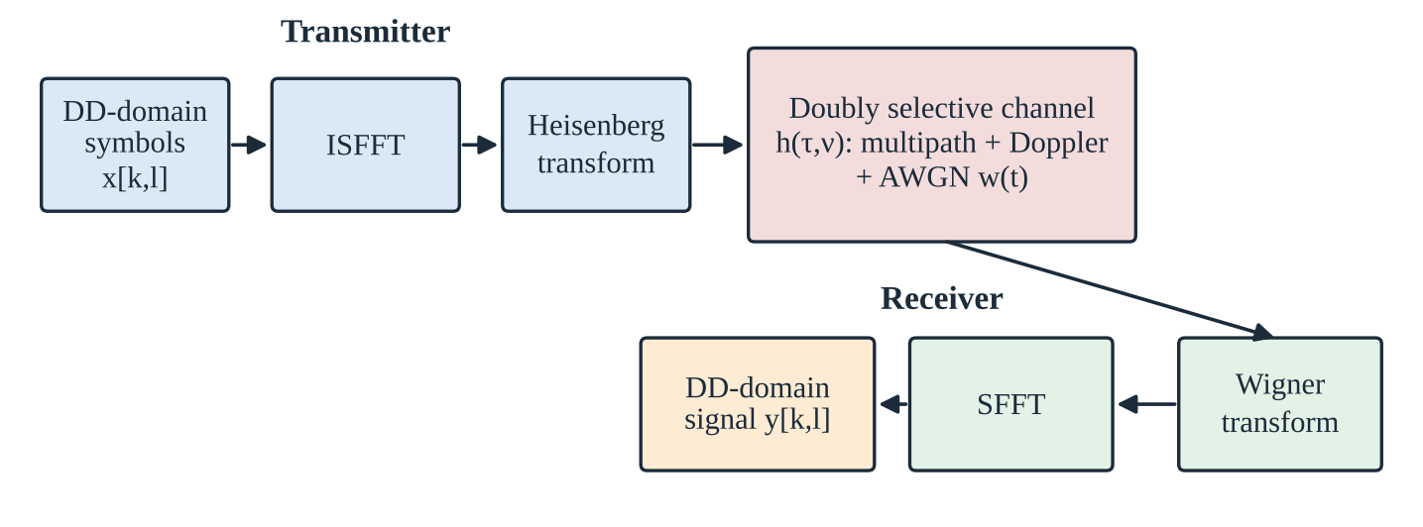
Figure 1: OTFS transmitter, doubly selective channel and receiver chain
The receiver reverses the operations: the Wigner transform converts the received waveform to the time-frequency domain and the SFFT returns it to the delay-Doppler domain, producing the received grid y[k, l]. This grid is the input to the proposed network.
ii. Doubly Selective Channel Model
The wireless channel is modelled as a sum of P propagation paths. Path i has a complex gain hᵢ, a delay τᵢ and a Doppler shift νᵢ, so that the delay-Doppler spreading function of the channel is the one given in Equation (3).
h(τ, ν) = Σᵢ hᵢ δ(τ − τᵢ) δ(ν − νᵢ), i = 1, …, P (3)
The number of paths P in typical mobile scenarios is small, so h(τ, ν) is sparse. The received waveform is the transmitted signal passed through this channel plus additive white Gaussian noise (AWGN) w(t). In the synthetic data used in this project, the path gains, delays and Doppler values are drawn randomly, and the noise is added at the chosen signal-to-noise ratio.
iii. Delay-Doppler Input-Output Relation
After the transforms, the received delay-Doppler grid is related to the transmitted grid by a two-dimensional circular convolution with the sampled channel, as in Equation (4), where κᵢ and ℓᵢ are the Doppler and delay indices of path i and (·)_N and (·)_M denote modulo operations.
y[k, l] = Σᵢ hᵢ′ x[ (k − κᵢ)_N , (l − ℓᵢ)_M ] + w[k, l] (4)
This relation shows that the received grid is a sum of a small number of shifted and scaled copies of the transmitted grid. The shifts encode the delays and Dopplers and the scale factors encode the path gains. The learning problem is therefore to recover the sparse delay-Doppler channel map and the Doppler information from y[k, l].
Table 2: Notation used in the report
Symbol | Meaning
N, M | Number of Doppler bins and delay bins of the delay-Doppler grid
x[k, l] | Transmitted symbol on the delay-Doppler grid
y[k, l] | Received signal on the delay-Doppler grid
P | Number of propagation paths
hᵢ, τᵢ, νᵢ | Gain, delay and Doppler shift of path i
κᵢ, ℓᵢ | Doppler index and delay index of path i
w[k, l] | Additive white Gaussian noise
ĥ | Estimated channel map produced by the channel head
d, d̂ | True and predicted normalised Doppler
λ | Weight of the Doppler loss in the combined loss

iv. Doppler Sensing
Besides the channel gains, the Doppler shifts of the paths give information about relative motion. In this project the Doppler-sensing output is a normalised Doppler value. In the generated data the true normalised Doppler takes sixteen discrete values from −1 to 0.875 in steps of 0.125, which matches a Doppler axis of sixteen bins. The predicted value is a continuous number, and a Low/High Doppler class is obtained from it, so the same output can be evaluated both as a regression and as a classification.
v. Problem Formulation
Let Y denote the received delay-Doppler grid with its real and imaginary parts as two channels. The aim is to learn a function f with parameters θ that maps Y to a channel estimate and a Doppler prediction, as in Equation (5).
( ĥ , d̂ ) = f_θ ( Y ) (5)
The parameters are chosen to minimise a combined loss that measures the error of the channel estimate with respect to the true channel and the error of the Doppler prediction with respect to the true Doppler. The exact form of this loss is given in the next chapter.
- Proposed Multi-Task CNN-Transformer

i. Overview of the Architecture
The proposed network has four main parts: a CNN encoder, a tokenisation step, a Transformer encoder and two task-specific output heads. The received delay-Doppler grid enters the CNN, which produces feature maps. These are reshaped into a sequence of tokens that is processed by the Transformer encoder to produce a shared representation. The channel head and the Doppler head each read this representation and produce their own output. The structure is shown in Figure 2.
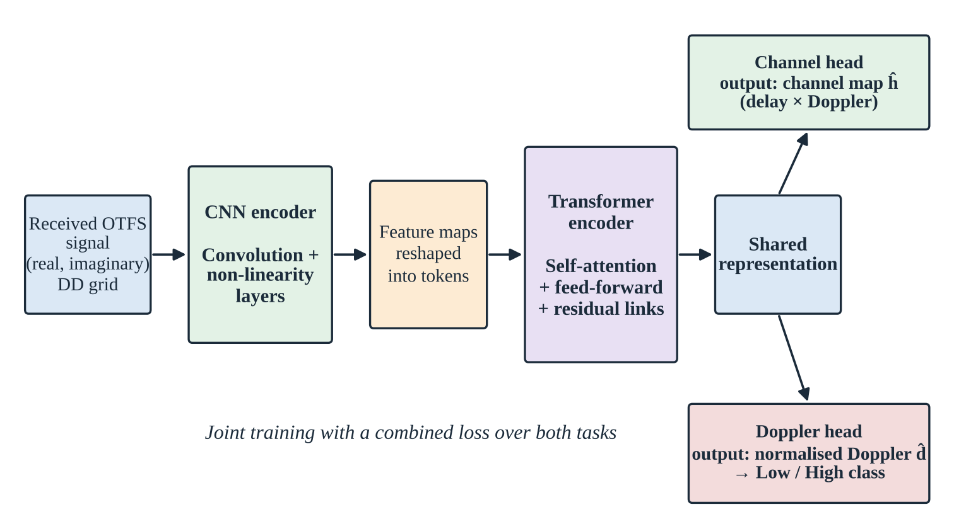
Figure 2: Architecture of the proposed multi-task CNN-Transformer
ii. Input Representation
The received OTFS signal is complex-valued. To use it with standard real-valued layers, its real and imaginary parts are stacked as two input channels over the delay-Doppler grid. In this way all the information in the complex signal is preserved, and the CNN can learn how the two components interact. The grid is processed as a two-dimensional image with two channels.
iii. CNN Feature Extractor
The first stage is a stack of convolutional layers with non-linear activations. Each layer applies learnable filters that respond to local patterns in the delay-Doppler grid, such as the energy spot of a path and its immediate surroundings caused by noise and fractional Doppler. Early layers capture simple local structure, while deeper layers combine these into richer descriptions. The output of the CNN is a set of feature maps that summarises the local content of the received signal.
iv. Tokenisation and Transformer Encoder
The feature maps are reshaped into a sequence of tokens, each token describing one location or patch of the delay-Doppler grid. The Transformer encoder then processes this sequence. Using self-attention, each token can gather information from every other token, so the network can learn long-range relationships between delay-Doppler bins that are far apart in the grid and cannot be seen by local filters alone. The encoder follows the standard structure of multi-head self-attention, a position-wise feed-forward network, residual connections and layer normalisation [3]. Its output is the shared representation used by both tasks.
v. Task-Specific Output Heads
Two separate output heads read the shared representation.
- Channel head: produces the estimated channel map ĥ on the delay-Doppler grid. This is the quantity compared with the true channel in the channel estimation results.
- Doppler head: produces a single normalised Doppler prediction d̂. This value is evaluated as a regression against the true normalised Doppler, and a Low/High class decision is derived from it for classification and ROC analysis.
Keeping the heads separate lets each task have an output layer matched to its type of target, while the shared representation lets both tasks benefit from the same learned features.
Table 3: Summary of the network components
Component | Role | Output
Input | Real and imaginary parts of the received delay-Doppler grid | Two-channel grid
CNN encoder | Extracts local patterns and features | Feature maps
Tokenisation | Reshapes feature maps into a sequence of tokens | Token sequence
Transformer encoder | Learns long-range relations by self-attention | Shared representation
Channel head | Reconstructs the delay-Doppler channel | Channel map ĥ
Doppler head | Predicts the normalised Doppler | Value d̂ and Low/High class

vi. Multi-Task Loss Function
The two tasks are trained together with a combined loss, which is the quantity plotted as the training and validation loss in Chapter 6. It is the weighted sum given in Equation (6), where L_channel measures the error of the channel estimate, L_Doppler measures the error of the Doppler prediction and λ sets the relative importance of the Doppler task.
L_total = L_channel + λ · L_Doppler (6)
For regression-type outputs, errors of the form of the mean squared error are commonly used, as in Equation (7), where ĥ and h are the estimated and true channel maps and the sum runs over all grid positions.
MSE = (1 / NM) Σₖ Σₗ | ĥ[k, l] − h[k, l] |² (7)
vii. Training Strategy
The network is trained with mini-batch gradient-based optimisation on the training set. After every epoch the combined loss is also computed on a separate validation set that is not used for updating the weights. The training and validation losses are recorded for 25 epochs and compared. A growing gap between them would indicate over-fitting, while both decreasing together indicate that the model is learning features that generalise. This monitoring also gives an early indication of unstable behaviour, such as sudden spikes in the validation loss.
viii. Design Rationale
The choice of a CNN followed by a Transformer has three reasons. First, the local structure of a delay-Doppler path is well captured by convolutions, which are efficient and robust to small shifts. Second, the relationship between several paths of the same channel is global, and self-attention can relate distant bins directly. Third, sharing the backbone between the two tasks reduces duplicated computation and allows the channel and Doppler outputs to reinforce each other, in line with the multi-task learning principle described in Chapter 2.
- Implementation and Experimental Setup

i. Software Requirements
The project is implemented in Python and developed in Google Colab and VS Code. The deep learning model is built with TensorFlow/Keras, numerical work is done with NumPy, evaluation uses Scikit-learn, and plots are produced with Matplotlib. The requirements are summarised in Table 4.
Table 4: Software requirements
Item | Specification
Programming language | Python
Development environment | Google Colab / VS Code
Libraries | NumPy, Pandas, Matplotlib
Deep learning framework | TensorFlow / Keras
Machine learning utilities | Scikit-learn (metrics, ROC and confusion matrix)
Operating system | Windows 10 / 11

ii. Dataset Generation
Since real high-mobility OTFS measurements are difficult to obtain, a synthetic dataset is generated. Each sample consists of a randomly generated multipath channel on the delay-Doppler grid, the corresponding received OTFS signal and the true normalised Doppler value. A few propagation paths with random gains, delays and Doppler shifts are drawn for each sample, the signal is passed through the channel and additive white Gaussian noise is added. In total 5,800 synthetic samples are generated and divided into training, validation and test partitions.
The true channel maps are sparse: only a few delay-Doppler bins carry significant energy. This is visible in the true channel panel of Figure 9, where four bright bins stand out on an otherwise empty grid. The generated normalised Doppler takes sixteen discrete values between −1 and 0.875, as described in Chapter 3.
iii. Project Workflow
The work was carried out in six steps, shown in Figure 3. Synthetic OTFS channels are generated with multipath and Doppler effects, noise is added and the delay-Doppler input is prepared, the CNN extracts local features, the features are reshaped into tokens for the Transformer, the joint model is trained, and finally the predictions are evaluated.
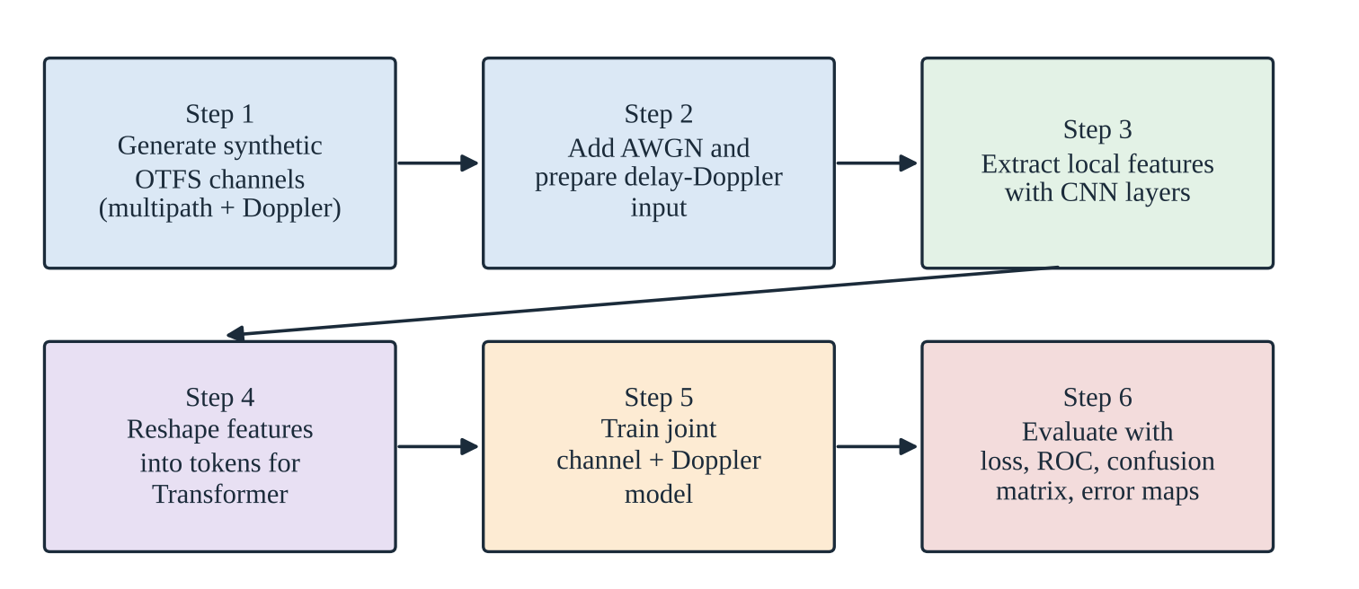
Figure 3: Project workflow from data generation to evaluation
iv. Simulation Parameters
Table 5: Simulation and data parameters
Parameter | Specification
Signal representation | OTFS-like delay-Doppler grid
Input channels | Two (real and imaginary components)
Channel model | Synthetic multipath channel with Doppler
Noise | Additive white Gaussian noise (AWGN)
Dataset size | 5,800 synthetic samples
Channel map size in results | 16 × 16 (delay bins × Doppler bins)
Normalised Doppler levels | 16 values from −1 to 0.875, step 0.125
Training length | 25 epochs
Classification evaluation set | 450 samples (Low: 188, High: 262)

v. Evaluation Metrics
The metrics used to evaluate the two tasks are defined in Table 6. Channel estimation is assessed through the error between the estimated and true channel maps, shown as an absolute error map in this report. Doppler prediction is assessed both as a regression and, after splitting the normalised Doppler into Low and High classes, as a classification problem using the confusion matrix and the ROC curve [7].
Table 6: Evaluation metrics
Metric | Definition | Used for
MSE | Mean of squared differences between estimate and truth | Channel estimation
NMSE | MSE divided by the energy of the true channel | Channel estimation
MAE / RMSE | Mean absolute error / square root of MSE | Doppler regression
Accuracy | (TP + TN) / total samples | Doppler classification
Precision | TP / (TP + FP) | Doppler classification
Recall | TP / (TP + FN) | Doppler classification
F1-score | Harmonic mean of precision and recall | Doppler classification
ROC-AUC | Area under true positive rate versus false positive rate curve | Doppler classification

vi. Experimental Procedure
The model is trained for 25 epochs on the training partition, and the combined loss on the validation partition is recorded after every epoch. After training, the model is applied to held-out samples. The predicted normalised Doppler is compared with the true value in a scatter plot, converted to a Low/High decision to build the confusion matrix and varied over all decision thresholds to obtain the ROC curve. The predicted channel is compared with the true channel on the delay-Doppler grid and the absolute error is displayed as a map. The results are given in the next chapter.
- Results and Discussion

i. Training and Validation Loss
Figure 4 shows the combined loss of the model over 25 epochs for the training and validation sets. Both losses drop sharply in the first few epochs: the training loss starts near 0.95 and the validation loss near 0.69, and by epoch 5 both are close to 0.37. From epoch 6 to about epoch 15 the curves decrease slowly and stay close to each other around 0.33 to 0.35, after which they fall again as the network refines its predictions. At the last epoch the training loss is about 0.08 and the validation loss about 0.14.
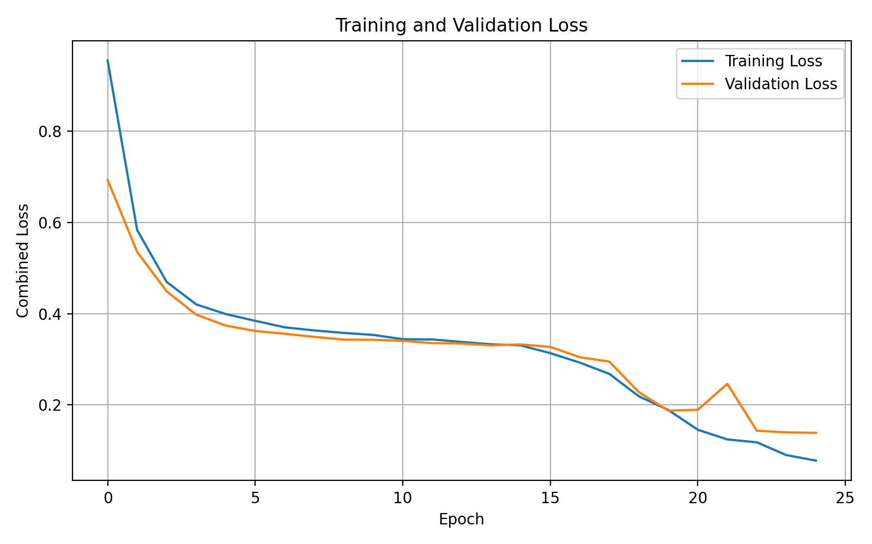
Figure 4: Training and validation loss over 25 epochs
Table 7: Approximate loss values read from the curves in Figure 4
Epoch | Training loss | Validation loss
0 | 0.95 | 0.69
5 | 0.38 | 0.36
10 | 0.34 | 0.34
15 | 0.31 | 0.33
20 | 0.15 | 0.19
21 | 0.12 | 0.25
24 | 0.08 | 0.14

Two observations are worth noting. First, the validation loss is lower than the training loss in the early epochs, which is common when the training loss is averaged while the weights are still changing quickly within an epoch. Second, there is a brief spike in the validation loss near epoch 21, which recovers by the next epoch; this indicates a temporary instability rather than a persistent problem. The gap between the final training loss (0.08) and validation loss (0.14) is small, which shows stable learning with only mild over-fitting. The absence of a diverging validation curve confirms that the model generalises to unseen data.
ii. Doppler Regression Performance
Figure 5 compares the true normalised Doppler with the predicted value for the evaluation samples. The red dashed line represents ideal prediction. The predictions follow this line across the full range from −1 to 0.875, which shows that the Doppler head has learned the relation between the received signal and the Doppler. The vertical columns of points arise because the true Doppler takes sixteen discrete values.
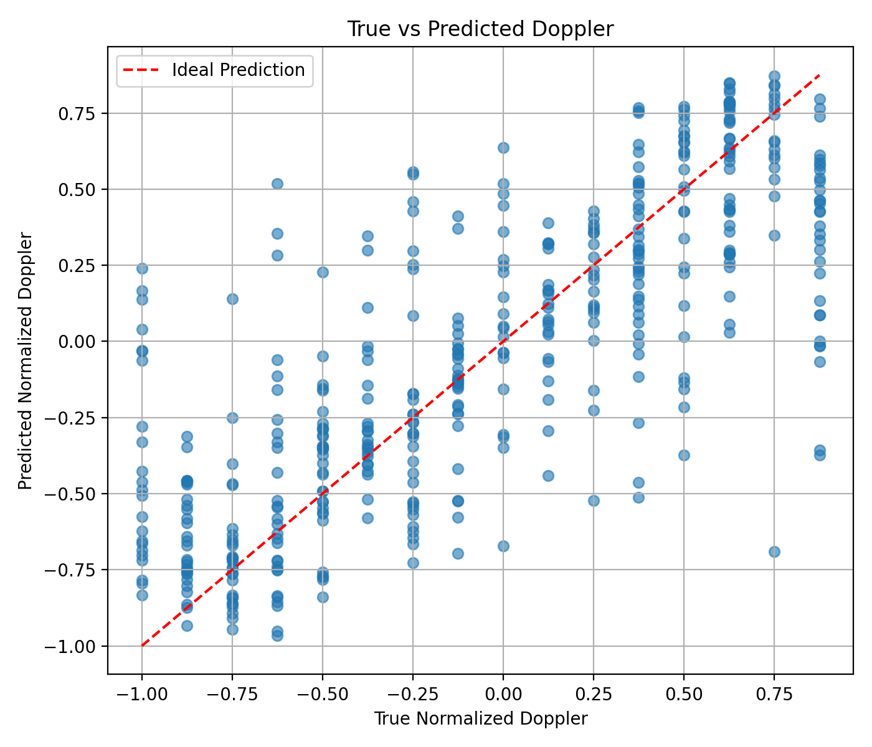
Figure 5: True versus predicted normalised Doppler
Predictions are closest to the ideal line in the intermediate range, roughly from −0.5 to −0.25 on the negative side and from 0.25 to 0.6 on the positive side. At the extremes the model tends to pull its predictions toward the centre: for a true value of 0.875 the predictions are mostly between about 0.3 and 0.6, and for a true value of −1 many predictions lie between −0.5 and −0.8. This regression to the middle is a typical behaviour of a regressor when extreme values are rare or when noise obscures the signal. A few outliers also remain, for example a true value of 0.75 predicted close to −0.7, which shows that occasionally the network confuses signals of different Doppler.
iii. Doppler Classification Performance
To evaluate the Doppler output as a sensing decision, the normalised Doppler is split into Low and High classes. The confusion matrix for 450 evaluated samples is shown in Figure 6 and the counts are listed in Table 8.
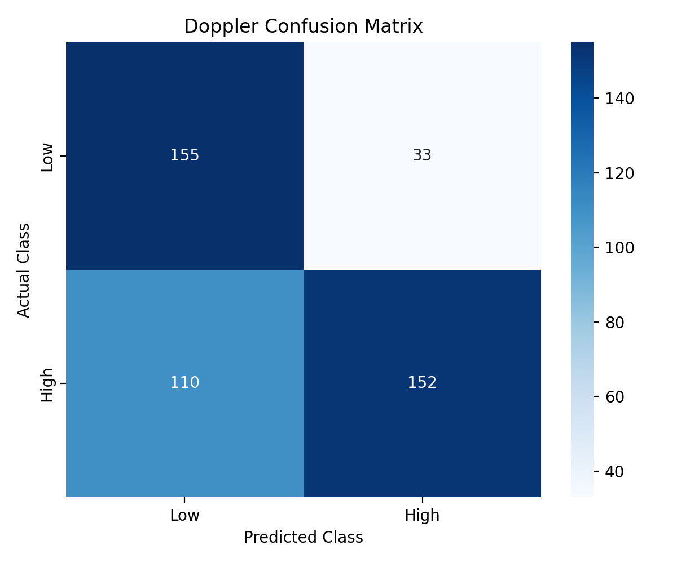
Figure 6: Confusion matrix for Low and High Doppler classes
Table 8: Confusion matrix counts
 | Predicted Low | Predicted High
Actual Low (188) | 155 (true negatives) | 33 (false positives)
Actual High (262) | 110 (false negatives) | 152 (true positives)

From these counts the overall accuracy is (155 + 152) / 450 = 68.2%. For the High class the precision is 152 / 185 = 82.2% and the recall is 152 / 262 = 58.0%, giving an F1-score of 0.680. For the Low class the precision is 155 / 265 = 58.5% and the recall is 155 / 188 = 82.4%, giving an F1-score of 0.684. The balanced accuracy, the mean of the two recalls, is 70.2%, and the Matthews correlation coefficient is 0.41, which indicates a clearly positive but moderate association between predictions and truth. The class-wise values are summarised in Table 9 and plotted in Figure 7.
Table 9: Class-wise classification metrics
Class | Precision | Recall | F1-score | Support
Low | 0.585 | 0.824 | 0.684 | 188
High | 0.822 | 0.580 | 0.680 | 262
Overall accuracy | 0.682 |  |  | 450

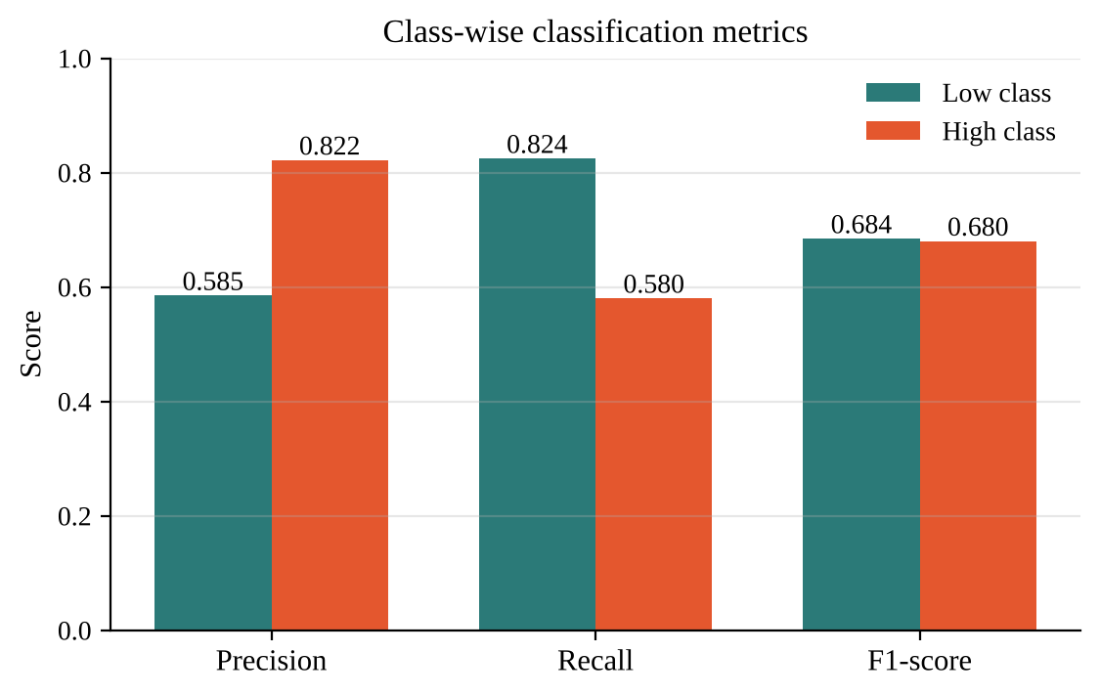
Figure 7: Precision, recall and F1-score for the Low and High classes
The model is therefore cautious in declaring a High Doppler: when it does so it is usually right (82.2% precision), but it misses 110 of the 262 High samples by calling them Low. Only 33 of the 188 Low samples are wrongly called High, a false positive rate of 17.6%. The bias toward Low is consistent with the compression of high Doppler predictions toward the centre seen in Figure 5, because predicted values that fall short of the decision boundary are labelled Low.
iv. ROC Analysis
The ROC curve in Figure 8 shows the trade-off between the true positive rate and the false positive rate as the decision threshold is varied. The area under the curve (AUC) is 0.781, well above the value of 0.5 expected from random guessing and clearly below the perfect value of 1. An AUC of 0.781 means that if one High sample and one Low sample are chosen at random, the model gives the High sample a higher score about 78% of the time [7].
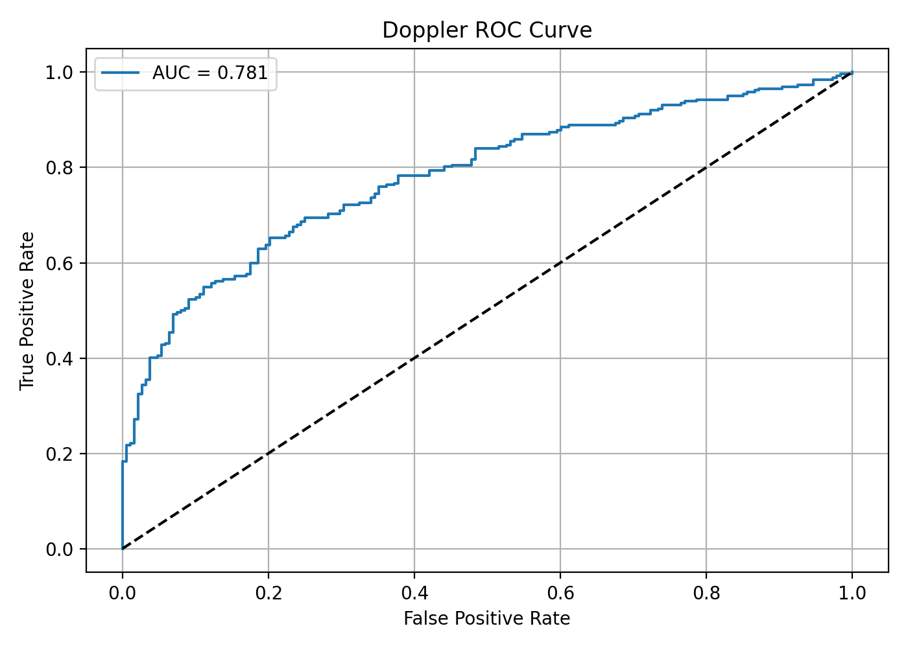
Figure 8: ROC curve for Doppler classification (AUC = 0.781)
Table 10: Approximate ROC operating points read from Figure 8
False positive rate | True positive rate | Comment
0.10 | about 0.52 | Very few false alarms
0.18 | about 0.58 | Matches the confusion matrix (0.176, 0.580)
0.20 | about 0.65 | Better recall at small cost
0.40 | about 0.78 | Higher recall, more false alarms

The confusion matrix in Figure 6 is a single point on this curve, with a false positive rate of 0.176 and a true positive rate of 0.580. Moving the decision threshold toward Low would raise the recall of the High class, for example about 0.65 at a false positive rate of 0.2, at the price of more false alarms. The threshold can therefore be selected according to the application: a system that must not miss high Doppler conditions would accept more false alarms, whereas a system that prefers confident detections would keep the stricter threshold.
v. Channel Estimation Performance
Figure 9 compares the true channel, the estimated channel and their absolute error on the 16 × 16 delay-Doppler grid for one test sample. The true channel is sparse and contains four significant paths. The estimated channel reproduces the same structure: the dominant spot near the bottom of the grid, the spot near delay 2 and Doppler 4 and the spot at the origin are all clearly present at the correct locations.
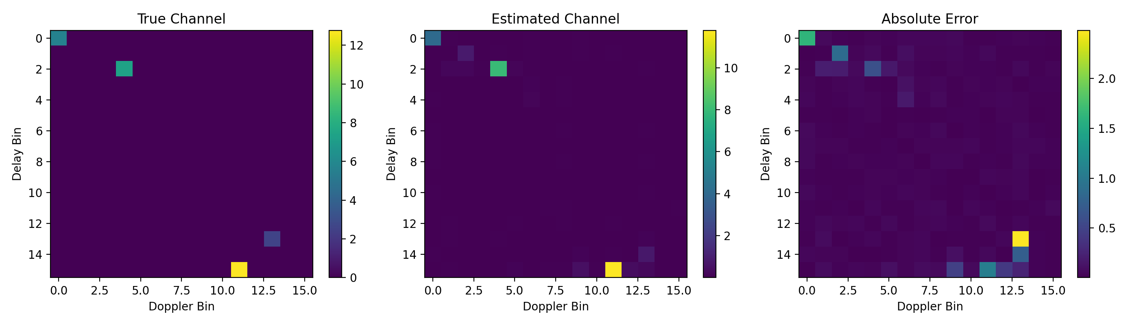
Figure 9: True channel, estimated channel and absolute error
The colour scales show that the strongest path has an amplitude of about 12.8 in the true channel and about 11.7 in the estimate, so the largest peak is recovered to within roughly 9%. The absolute error is small over most of the grid. The largest error, about 2.4, occurs at the weak path near delay 13 and Doppler 13, which the estimate places partly in the neighbouring delay bin, so a second error spot of about 1 appears just below it. Smaller errors of about 1 to 2 are visible at the strong paths at the origin and near delay 2, Doppler 4, and small spurious responses appear in a few bins close to the paths. These results show that the network is able to locate the dominant paths, while the precise amplitude of weaker paths is harder to recover.
Table 11: Observations from the channel estimation result
Observation | Description
Path locations | All four dominant paths appear at the correct delay-Doppler positions in the estimate
Strongest path | Peak amplitude about 12.8 (true) versus about 11.7 (estimated)
Largest error | About 2.4 at the weak path near delay 13, Doppler 13, partly displaced by one delay bin
Background | Absolute error is small over most of the grid, with minor spurious responses near the paths

vi. Overall Discussion
Taken together, the results show that the shared CNN-Transformer learns both tasks from the same representation. Training is stable and converges, the Doppler predictions follow the ideal relation with expected compression at the extremes, the classification quality is moderate with a high-precision, lower-recall behaviour, and the channel estimate recovers the main structure of the sparse channel. Table 12 gives an overview.
Table 12: Summary of results
Task | Evidence | Outcome
Training | Loss 0.95 to 0.08 (train), 0.69 to 0.14 (validation) | Stable convergence over 25 epochs
Doppler regression | True versus predicted scatter, 16 Doppler levels | Follows the ideal line, weaker at extremes
Doppler classification | Accuracy 68.2%, F1 about 0.68 | Precision 82.2%, recall 58.0% for High
Ranking quality | ROC AUC 0.781 | Clearly better than random
Channel estimation | 16 × 16 delay-Doppler map | Dominant paths recovered, largest error about 2.4

The main strengths are the stable learning behaviour and the ability of a single backbone to serve both outputs. The main weaknesses are the moderate recall for the High class, the compression of extreme Doppler predictions and the error on weak paths. These weaknesses suggest the improvements discussed in the next chapter, such as weighting the Doppler loss, adjusting the decision threshold, increasing the amount of training data at the extremes and training under a wider range of noise levels.
vii. Comparison with the Project Plan
The project plan presented at the second review contained four remaining tasks. Table 13 compares the plan with what has been achieved in this report.
Table 13: Planned work versus achieved status
Planned task | Status | Remarks
Complete Transformer encoder | Completed | Self-attention layers operate on CNN-generated tokens
Develop multi-task output heads | Completed | Separate channel and Doppler heads on a shared representation
Train and evaluate the model | Completed for the results shown | Loss, scatter, confusion matrix, ROC and channel error maps reported
Baseline comparison and SNR study | Planned | Left as future work

- Conclusion and Future Scope

i. Conclusion
This project developed a multi-task CNN-Transformer for joint OTFS channel estimation and Doppler-sensing prediction. The CNN extracts local features from the delay-Doppler representation of the received signal, the Transformer encoder models the relationships between distant bins and two task-specific heads produce the channel estimate and the normalised Doppler prediction from one shared representation.
The model was trained on synthetic multipath OTFS data with noise and converged smoothly over 25 epochs, with the combined loss falling from about 0.95 to 0.08 for training and from about 0.69 to 0.14 for validation. The Doppler predictions follow the ideal line across the normalised range. As a classifier of Low and High Doppler the model reaches 68.2% accuracy, 82.2% precision and 58.0% recall for the High class, and a ROC area under the curve of 0.781. The estimated channel correctly locates the dominant delay-Doppler paths, with a largest absolute error of about 2.4 on a weak path. These results support the idea that channel estimation and Doppler sensing can be learned jointly from a common feature representation.
ii. Limitations
- The data are simulated, so the behaviour on measured channels is not yet known.
- The recall for high Doppler values is moderate and extreme Doppler values are predicted closer to the centre than they should be.
- The amplitude of weak channel paths is not recovered as accurately as that of strong paths.
- A full comparison with conventional estimators and single-task networks over a range of signal-to-noise ratios has not yet been carried out.
iii. Future Scope
- Report MSE, NMSE, MAE and RMSE over a range of signal-to-noise ratios and compare them with conventional estimation approaches and with standalone CNN and Transformer models.
- Improve the recall of the High Doppler class by tuning the loss weighting, applying class weights or adjusting the decision threshold along the ROC curve.
- Train with more samples at extreme Doppler values and with wider variations of noise, delay and mobility.
- Analyse computational complexity, model size and inference time to judge real-time feasibility.
- Extend the model to fractional Doppler and delay values and to validate it on measured or ray-tracing based channel data.
References

[1] R. Hadani, S. Rakib, M. Tsatsanis, A. Monk, A. J. Goldsmith, A. F. Molisch and R. Calderbank, “Orthogonal Time Frequency Space Modulation,” in Proc. IEEE Wireless Communications and Networking Conference (WCNC), 2017.
[2] P. Raviteja, K. T. Phan and Y. Hong, “Embedded Pilot-Aided Channel Estimation for OTFS in Delay-Doppler Channels,” IEEE Transactions on Vehicular Technology, vol. 68, no. 5, pp. 4906-4917, 2019.
[3] A. Vaswani et al., “Attention Is All You Need,” in Advances in Neural Information Processing Systems (NeurIPS), 2017.
[4] Y. LeCun, L. Bottou, Y. Bengio and P. Haffner, “Gradient-Based Learning Applied to Document Recognition,” Proceedings of the IEEE, vol. 86, no. 11, pp. 2278-2324, 1998.
[5] R. Caruana, “Multitask Learning,” Machine Learning, vol. 28, pp. 41-75, 1997.
[6] A. Dosovitskiy et al., “An Image Is Worth 16x16 Words: Transformers for Image Recognition at Scale,” in International Conference on Learning Representations (ICLR), 2021.
[7] T. Fawcett, “An Introduction to ROC Analysis,” Pattern Recognition Letters, vol. 27, no. 8, pp. 861-874, 2006.
[8] I. Goodfellow, Y. Bengio and A. Courville, Deep Learning. Cambridge, MA, USA: MIT Press, 2016.

